# Question 1: PAC Chart

|  |  |
| --- | --- |
| **Given Data** | **Required Results** |
| - Transaction amount - Daily spending limit - Transactions per hour - Transaction country - Customer’s usual countries | - Suspicious transaction (Yes/No) - Reason (limit exceeded / foreign country / too many in short time) |
| **Processing** | **Solution Alternative** |
| - Keep running total of spending per day - Compare total spending against daily limit - Check if country belongs to customer's usual countries - Count transactions per hour → if > 3, flag as suspicious | 1. Decision-only approach  Use if–else conditions to check each rule separately |

# IPO Chart

|  |  |  |
| --- | --- | --- |
| Input | Process | Output |
| - Total spending amount - Transaction country - Number of transactions in one hour - Daily spending limit (fixed) - Allowed countries (pak, uae) - Maximum transactions per hour (3) | 1. Compare total spending with daily limit. 2. If total spending > limit → mark suspicious. 3. Check if country is in allowed list. 4. If not in list → mark suspicious. 5. Compare number of transactions in 1 hour with limit. 6. If transactions > 3 → mark suspicious. 7. If none of the above → mark transaction as normal. | - Suspicious: Daily limit exceeded - Suspicious: Foreign country - Suspicious: Transaction count exceeded - Normal transaction (if all conditions passed) |

# 2. Algorithm, Flowchart, and Pseudocode

## ALGORITHM

### **Algorithm**

1. **Start**
2. Initialize:
   * daily_limit ← 5000
   * transaction_count_hour ← 3
3. Input total_spending.
4. If total_spending greater than daily_limit then
   * Print "Suspicious, Daily Limit Exceeded"
   * Stop the program.
5. Input country.
6. If country is not "pak" and not "uae" then
   * Print "Suspicious Foreign Country"
   * Stop the program.
7. Input transactions (number of transactions in one hour).
8. If transactions greater than transaction_count_hour then
   * Print "Suspicious, Transaction count exceeded"
   * Stop the program.
9. If none of the above conditions are true, then
   * Print "Transaction is normal".
10. **End**

## PSEUDO CODE

BEGIN

SET daily_limit = 5000  
SET transaction_count_hour = 3  
 INPUT total_spending

IF total_spending > daily_limit THEN

PRINT "Suspicious, Daily Limit Exceeded"

EXIT

ENDIF  
 INPUT country

IF country ≠ "pak" AND country ≠ "uae" THEN

PRINT "Suspicious Foreign Country"

EXIT

ENDIF  
 INPUT transactions

IF transactions > transaction_count_hour THEN

PRINT "Suspicious, Transaction count exceeded"

EXIT

ENDIF

PRINT "Transaction is normal"

END

## FLOW CHART

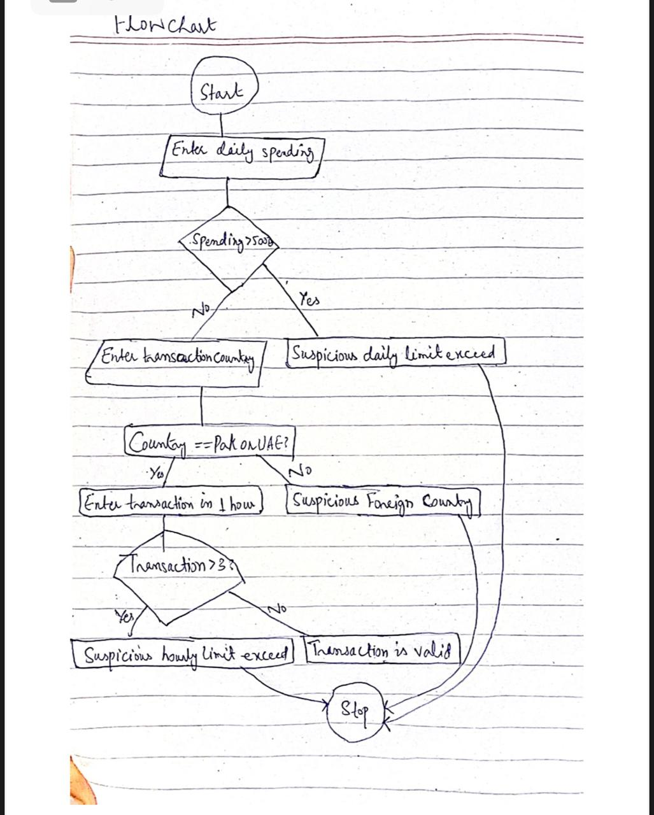

**IC Chart** :  
  
  
